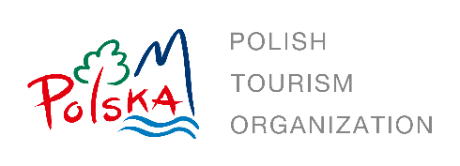
REQUEST FOR PROPOSALS

Contact: Polish National Tourist Office (PNTO), Chicago, USA
Date of Issue: 8 February 2024
Deadline: 15 February 2024

The Polish National Tourist Office (PNTO), based in Chicago, is currently seeking an experienced American tour operator to collaborate with for a period of three months. The aim of this collaboration is to promote Polish tourism in the American market. The selected tour operator will be responsible for creating and executing various marketing activities, including email campaigns, ads on the booking portal, blog posts, social media engagement, webinars, and training sessions.

Section 1: TARGET DATES FOR THIS RFP
The following schedule summarizes significant target events for the RFP process. The dates may be changed by PNTO at its sole discretion.
- RFP issue date: 8 February 2024
- RFP close date: 15 February 2024
- Notification of awarded company: 16 February 2024

Section 2: CAMPAIGN OVERVIEW

Campaign execution period: 3 months

Target group: North American travel advisors

Section 3: KPI
- Reach: Number or impressions
- Number of clicks (CTR)
- PAX production increase as compared to the same timeline in 2023

Section 4: BUDGET
- Total budget is 25,000 USD gross

Section 5: SCOPE OF WORK (SOW) FOR BID
You are asked to submit a proposal that includes the following information:
- Campaign overview
- Estimated impressions
- Estimated PAX production increase

Section 6: ENQUIRIES:
- Questions regarding requirements and scope of work will be received up to
14 February 2024 via email only at bartosz.szajda@pot.gov.pl and maciej.olchawa@pot.gov.pl.
- Questions submitted after 14 February 2024 will not be responded to.

No verbal inquiries or verbal requests for clarifications will be accepted.
Section 7: SUBMISSION REQUIREMENTS
Proposals should be emailed to bartosz.szajda@pot.gov.pl and maciej.olchawa@pot.gov.pl. Only the awarded company will be notified by email.

